Spotify Basic Database

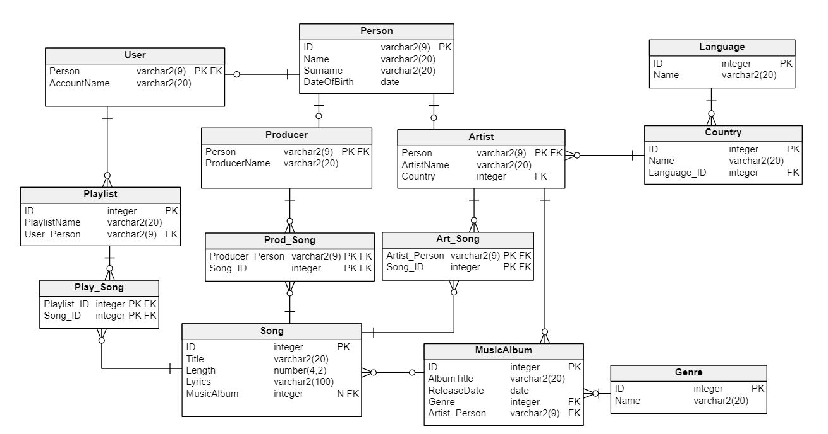

**Description**

This database is designed to manage information about existing music on Spotify.

It stores information mainly about the songs and albums available on the platform. Each song have a specific album, artist, producer, duration and lyrics. Database also stores information about users playlists and all the songs present on them for more accurate recommendations of new music for users in the future. We can also track all songs made by specific artist or producer. This database is the most basic database for a streaming platform.

**Functional Requirements**

User Management

* Registration: Users can register by providing necessary details (name, surname, date of birth).
* User Profiles: Users can view and manage their profiles (change or set account name)

Playlists

* Create Playlists: Users can create new playlists and assign a name to each playlist.
* Add and Remove Songs: Users can add songs to their playlists and remove songs from them.

Music Catalog

* Song Listing: Display a catalog of songs with their titles, lengths, lyrics, and associated albums.
* Album Listing: Display information about albums, including titles, release dates, genre, and associated songs.
* Artist Information: Provide details about artists, such as their name, country, and associated songs.

Search Functionality

* Search by Song Title, Artist, or Album: Users can search for songs, artists, or albums by their titles, artist names, or album titles respectively.
* Lyrics Search: Users can search for songs by lyrics.

Relationships

* Artist-Song Associations: Artists are associated with songs they've created.
* Producer-Song Associations: Producers are linked to the songs they've produced.
* Playlist-Song Associations: Playlists contain specific songs selected by users.

**Questions it can answer:**

1. How many songs are there in each playlist?
2. Which artists have released the highest number of songs, and what are their counts?
3. How many songs are categorized under each specific music genre?
4. Which albums were released in the specific year?
5. What songs in a particular playlist contain specific keywords within their lyrics?